# ICS 3104

# Lab 3

# JavaScript, Date object and time zones.

**Preliminaries**

This lab is a continuation of Lab 2.

Here, we read current user UTC time and its offset as shown below. We use JavaScript.

Proceed as follows

Include JQuery and timezone.js in the head section of your lab1.php as shown.

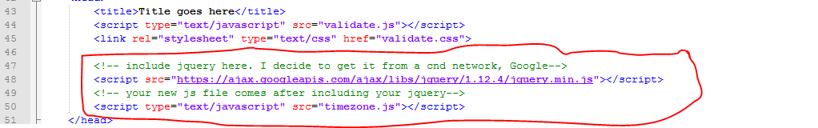

Include two form controls in your form to hold your UTC time and time zone offset as shown below

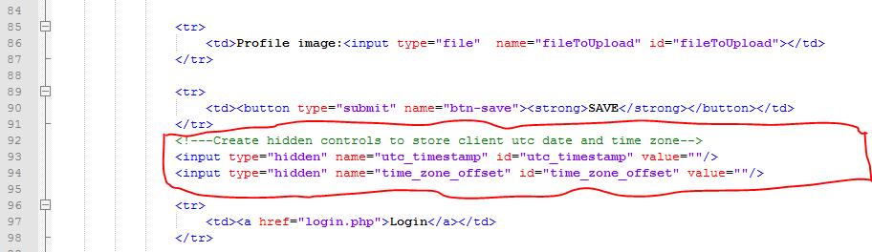

Now create timezone.js file as shown

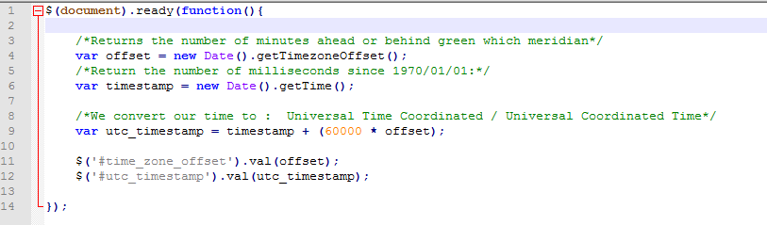

Explain what is happening in line 11 and 12.

You notice that we read the date and then add offset to get UTC time. That means when reading from database, you will subtract the offset to get the client time.

Now when you submit your form this time, you are submitting 2 extra fields. So you will modify your PHP code in lab1.php as follows.

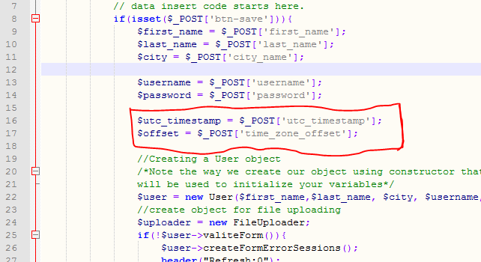

Now proceed by doing the following

Alter your table user by adding two columns to hold the UTC time and offset

* Modify the User class constructor appropriately to accommodate the new data.
* Add the extra member variables in the class User plus their getters and setters.
* Proceed and modify the save() function appropriately to add the extra data into the database.

# A fresh challenge!

Reading client date may not be accurate if the user has not set correct time in his/her machine.

Explain step by step how you can deal with this problem.

***-This lab is complete-***